THIS IS A PRACTICE ASSESSMENT. Show formulas, substitutions, answers (in spaces provided) and units!

The following questions are about gravitational potential energy, potential, and potential gradient.
1. Define gravitational potential. _________________________________________________________
__________________________________________________________________________________

2. Find the change in gravitational potential in moving from Earth’s surface to 3 Earth radii (from Earth’s center). 2. _________________

3. The gravitational potential in the vicinity of a planet changes from -0.85×10⁷ J kg⁻¹ to -0.79×10⁷ J kg⁻¹ in moving from r = 1.80×10⁷ m to r = 1.82×10⁷ m. What is the gravitational field strength in that region? 3. _________________

Four point masses, each of which has a mass of 875 kg, are arranged in a circle of radius 2250 m as shown.
4. What is the gravitational potential at the center of the configuration?
4. _________________

5. What is the work done by gravity in bringing a 150-kg mass from very far away to the center of the configuration? 5. _________________

The following questions are about escape speed and orbital speed about a planet whose rotational period is 15.5 hours.
6. What is the escape speed from a planet whose mass is 2.00×10²⁶ kg and whose radius is 4.00×10⁷ m? 6. _________________

7. What is the orbital speed about this planet at an altitude of one planet radius?
7. _________________

8. Using Kepler’s 3rd law find the period of a satellite that is three planet radii above the surface.
8. _________________

9. At what altitude would a satellite be if it were in synchronous orbit about the planet?
9. _________________

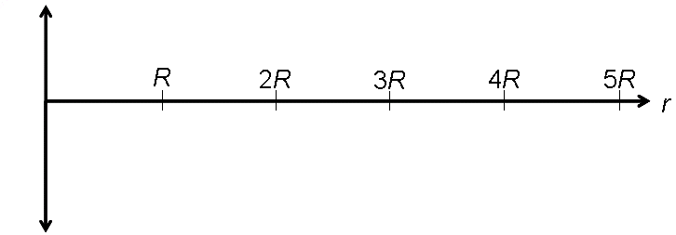
The following questions have to do with the energy of an orbiting mass.
10. Sketch graphs showing the variation with orbital radius of the kinetic energy, gravitational potential energy and total energy of a satellite. Be sure to include all graphs on a single energy vs. radius coordinate system. 10._in graph_
The following questions are about electrostatic potential energy, potential, and potential gradient.
11. Define electrostatic potential energy. ___________________________________________________
__________________________________________________________________________________

12. Calculate the electrostatic potential 1.75×10⁻¹⁰ m from a proton. 12. ________________

13. The electrostatic potential in the vicinity of a charge changes from -2.87 V to -2.54 V in moving from r = 2.82×10⁻³ m to r = 2.85×10⁻³ m. What is the electric field strength in that region? Is the charge (-) or is it (+)? _____. 13. ________________

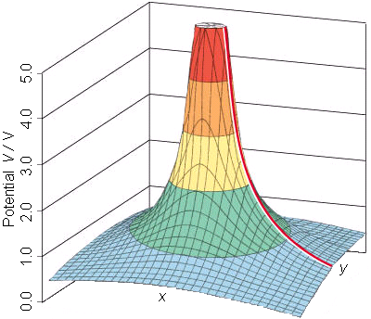
An equipotential surface caused by a charge is shown to the right.
14. Find the electric field strength at the point P. The vertical axis is measured in J C⁻¹ and the grid lines in the x and y directions are in cm.
P

14. ________________

Q

15. Find the electric field strength at the point Q. How can you visually tell the field is stronger at P than it is at Q? 15. ________________
___________________________________________

16. How do you know that this surface is not caused by a mass?
__________________________________________________________________________________

The following questions are about an electron moving in an electrostatic field.
17. An electron is brought from infinity to a distance of 1.75 mm from a charge of -285 C. How much work was done by the electrostatic field on the electron? Does your answer depend on the path taken by the electron? ________. 17. ________________

18. An electron moves from a point in space where the potential is 100.0 V to another point where the potential is 200.0 V. If it started from rest, what is its speed at the end of this trip?
18. ________________

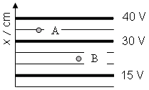
A diagram showing equipotential surfaces set up by some sort of a charge configuration is shown.
19. Find the electric field strength at the points A and B.
19. ________________

20. What is the force acting on an electron if placed at the point A? Which way does it point? 20. ________________
________________
21. Describe a physical scenario in which such a field could be set up in a lab.
__________________________________________________________________________________

